10.
Configuring ASA Basic Settings and Firewall Using CLI
a.
Configure basic ASA settings and interface security levels using CLI
b.
Configure routing, address translation, and inspection policy using CLI
c.
Configure DHCP, AAA, and SSH
d.
Configure a DMZ, Static NAT, and ACLs

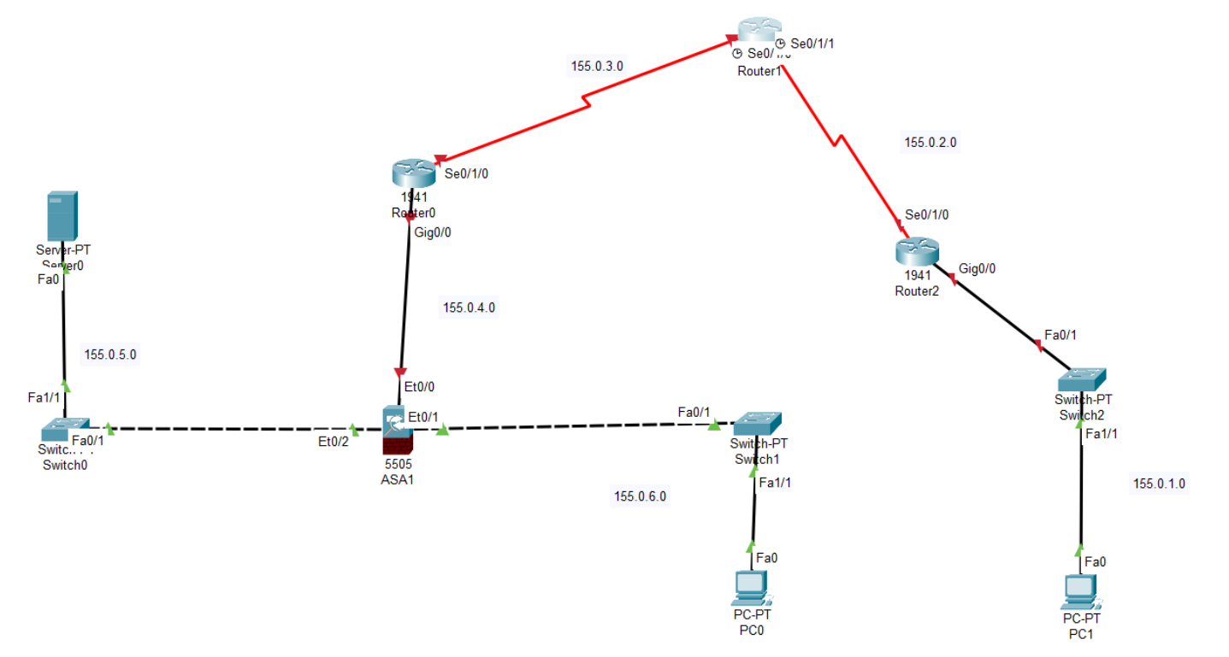

Network | Purpose
155.0.1.0/24 | PC1 LAN (Right side)
155.0.2.0/30 | R1–R2 serial
155.0.3.0/30 | R0–R1 serial
155.0.4.0/24 | R0–ASA (outside)
155.0.5.0/24 | Server LAN (DMZ)
155.0.6.0/24 | PC0 LAN (inside)

🔹 STEP 1 — Configure Router0 (Left Router)
enable
configure terminal
hostname R0
interface g0/0
ip address 155.0.4.1 255.255.255.0
no shutdown
interface s0/1/0
ip address 155.0.3.1 255.255.255.252
clock rate 64000
no shutdown
exit
ip route 155.0.1.0 255.255.255.0 155.0.3.2
ip route 155.0.6.0 255.255.255.0 155.0.4.2
ip route 155.0.5.0 255.255.255.0 155.0.4.2
end
write memory

🔹 STEP 2 — Configure Router1 (Top Router)
enable
configure terminal
hostname R1
interface s0/1/1
ip address 155.0.3.2 255.255.255.252
no shutdown
interface s0/1/0
ip address 155.0.2.1 255.255.255.252
clock rate 64000
no shutdown
exit
ip route 155.0.4.0 255.255.255.0 155.0.3.1
ip route 155.0.6.0 255.255.255.0 155.0.3.1
ip route 155.0.5.0 255.255.255.0 155.0.3.1
ip route 155.0.1.0 255.255.255.0 155.0.2.2
end
write memory

🔹 STEP 3 — Configure Router2 (Right Router)
enable
configure terminal
hostname R2
interface g0/0
ip address 155.0.1.1 255.255.255.0
no shutdown
interface s0/1/0
ip address 155.0.2.2 255.255.255.252
no shutdown
exit
ip route 155.0.4.0 255.255.255.0 155.0.2.1
ip route 155.0.6.0 255.255.255.0 155.0.2.1
ip route 155.0.5.0 255.255.255.0 155.0.2.1
end
write memory

🔹 STEP 4 — Configure ASA 5505 (Main Part 🔥)
We will configure:
outside → 155.0.4.2
inside → 155.0.6.1
dmz → 155.0.5.1
NAT
Default route
ACL

🔸 Enter ASA CLI
enable
configure terminal
hostname ASA1

🔸 Configure Interfaces
interface vlan 1
nameif inside
security-level 100
ip address 155.0.6.1 255.255.255.0
no shutdown
interface vlan 2
nameif outside
security-level 0
ip address 155.0.4.2 255.255.255.0
no shutdown
interface vlan 3
nameif dmz
security-level 50
ip address 155.0.5.1 255.255.255.0
no shutdown

🔸 Assign Physical Ports
interface ethernet0/0
switchport access vlan 2
interface ethernet0/1
switchport access vlan 1
interface ethernet0/2
switchport access vlan 3

🔸 Configure Default Route
route outside 0.0.0.0 0.0.0.0 155.0.4.1

🔸 Configure PAT (Inside to Outside Internet)
object network INSIDE-NET
subnet 155.0.6.0 255.255.255.0
nat (inside,outside) dynamic interface

🔸 Configure Static NAT for Server (DMZ to Outside)
object network DMZ-SERVER
host 155.0.5.10
nat (dmz,outside) static 155.0.4.10

🔸 Allow Outside Access to Server (HTTP Example)
access-list OUTSIDE-IN permit tcp any host 155.0.4.10 eq 80
access-group OUTSIDE-IN in interface outside

🔸 Save Configuration
write memory

🔹 STEP 5 — Configure PC0 (Inside LAN)
Desktop → IP Configuration
IP Address: 155.0.6.10
Subnet Mask: 255.255.255.0
Default Gateway: 155.0.6.1

🔹 STEP 6 — Configure Server (DMZ)
Desktop → IP Configuration
IP Address: 155.0.5.10
Subnet Mask: 255.255.255.0
Default Gateway: 155.0.5.1
Enable HTTP service:
Services → HTTP → ON

🔹 STEP 7 — Configure PC1 (Right LAN)
IP Address: 155.0.1.10
Subnet Mask: 255.255.255.0
Default Gateway: 155.0.1.1

🔥 TESTING
From PC0:
ping 155.0.1.10
ping 155.0.5.10
From PC1:
ping 155.0.4.10
Browser test:
http://155.0.4.10

Configure and Verify a Site-to-Site IPsec VPN Using CLI

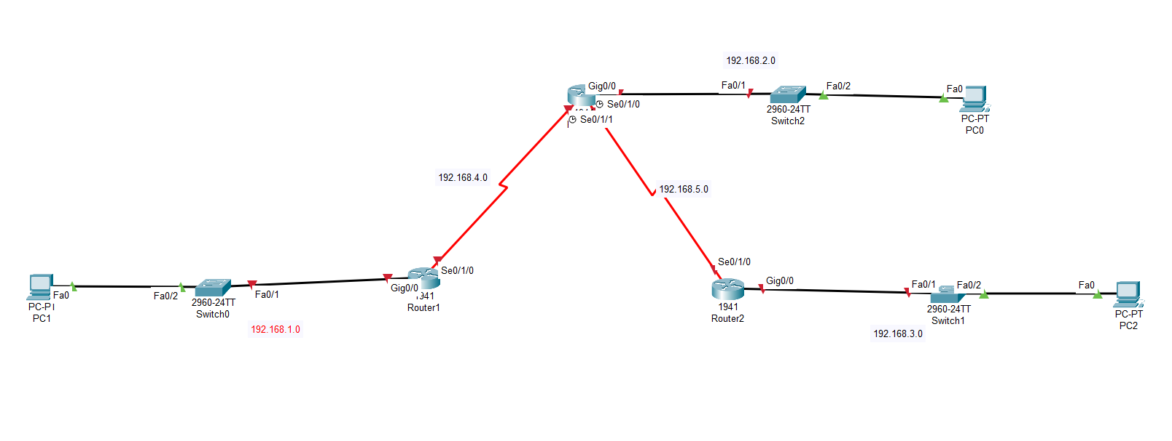

1️⃣ Addressing Plan
Device | Interface | IP
Router1 | G0/0 | 192.168.1.1 /24
Router1 | S0/1/0 | 192.168.4.2 /30
Router0 (ISP) | S0/1/0 | 192.168.4.1 /30
Router0 | S0/1/1 | 192.168.5.1 /30
Router0 | G0/0 | 192.168.2.1 /24
Router2 | S0/1/0 | 192.168.5.2 /30
Router2 | G0/0 | 192.168.3.1 /24
PCs:
PC | IP | Gateway
PC1 | 192.168.1.10 | 192.168.1.1
PC0 | 192.168.2.10 | 192.168.2.1
PC2 | 192.168.3.10 | 192.168.3.1

2️⃣ Router1 Configuration (Left Site)
enable
conf t
hostname Router1
interface g0/0
ip address 192.168.1.1 255.255.255.0
no shutdown
interface s0/1/0
ip address 192.168.4.2 255.255.255.252
no shutdown

Default Route to ISP
ip route 0.0.0.0 0.0.0.0 192.168.4.1

Phase 1 – ISAKMP Policy
crypto isakmp policy 10
encryption aes
hash sha
authentication pre-share
group 2
lifetime 86400
exit

Pre-shared key
crypto isakmp key cisco address 192.168.5.2

Phase 2 – Transform Set
crypto ipsec transform-set VPN-SET esp-aes esp-sha-hmac
mode tunnel

Interesting Traffic (VPN ACL)
access-list 110 permit ip 192.168.1.0 0.0.0.255 192.168.3.0 0.0.0.255

Crypto Map
crypto map VPN-MAP 10 ipsec-isakmp
set peer 192.168.5.2
set transform-set VPN-SET
match address 110

Apply Crypto Map
interface s0/1/0
crypto map VPN-MAP
exit

3️⃣ Router2 Configuration (Right Site)
enable
conf t
hostname Router2
interface g0/0
ip address 192.168.3.1 255.255.255.0
no shutdown
interface s0/1/0
ip address 192.168.5.2 255.255.255.252
no shutdown

Default Route
ip route 0.0.0.0 0.0.0.0 192.168.5.1

Phase 1
crypto isakmp policy 10
encryption aes
hash sha
authentication pre-share
group 2
lifetime 86400
exit

Pre-shared Key
crypto isakmp key cisco address 192.168.4.2

Phase 2
crypto ipsec transform-set VPN-SET esp-aes esp-sha-hmac
mode tunnel

VPN ACL
access-list 110 permit ip 192.168.3.0 0.0.0.255 192.168.1.0 0.0.0.255

Crypto Map
crypto map VPN-MAP 10 ipsec-isakmp
set peer 192.168.4.2
set transform-set VPN-SET
match address 110

Apply Crypto Map
interface s0/1/0
crypto map VPN-MAP
exit

4️⃣ ISP Router Configuration (Router0)
enable
conf t
hostname ISP
interface g0/0
ip address 192.168.2.1 255.255.255.0
no shutdown
interface s0/1/0
ip address 192.168.4.1 255.255.255.252
clock rate 64000
no shutdown
interface s0/1/1
ip address 192.168.5.1 255.255.255.252
clock rate 64000
no shutdown

Static Routes
ip route 192.168.1.0 255.255.255.0 192.168.4.2
ip route 192.168.3.0 255.255.255.0 192.168.5.2

5️⃣ Verification Commands

Check ISAKMP Phase 1
show crypto isakmp sa
Expected:
QM_IDLE

Check IPsec Phase 2
show crypto ipsec sa

Check Crypto Map
show crypto map

6️⃣ Test VPN Tunnel
Ping from PC1 → PC2
ping 192.168.3.10
First ping may fail, next should succeed.

7️⃣ Verify Encrypted Packets
On Router1:
show crypto ipsec sa
You should see:
pkts encrypt
pkts decrypt

